

Online Quizzer

PHP WEB DEVELOPMENT Track

Students

Abanoub Bekhiet

Ahmed Saad

Khalid walid

mario ayman

Habiba medhat

**Project Description:**

We developed an interactive online quiz platform designed to engage users by offering quizzes on various topics. The platform allows users to take quizzes, track their scores, and view detailed performance history over time. Admins have the ability to create and manage quizzes, set specific time limits, and access participant results for effective analysis. The platform is built with a robust backend using MySQL to store quiz data, user profiles, and scores. PHP and Laravel are utilized for managing quiz logic and user handling, while the frontend leverages HTML, CSS, and JavaScript to ensure smooth interactivity.

**Project Goals:**

* To provide a user-friendly platform for quiz-takers to assess their knowledge across diverse subjects.
* To offer a streamlined admin interface where quizzes can be created, edited, and managed efficiently.
* To ensure data integrity, with comprehensive tracking of user performance and results.
* To foster an engaging and educational experience through real-time feedback and performance monitoring.

**Users:**

* **General Users**: Individuals interested in taking quizzes, tracking their scores, and viewing their performance history over time.
* **Admins**: Users responsible for managing the platform by creating quizzes, setting time limits, and monitoring quiz results.

**Stakeholders:**

* **Admin Stakeholders**: Educators, trainers, or content creators who need a system to develop and manage quizzes for participants.
* **Participants/Users**: Learners or quiz enthusiasts who benefit from taking quizzes and tracking their results for self-assessment.
* **Platform Developers**: The development team responsible for maintaining and upgrading the platform for optimal user experience.

**User view**

Landing page

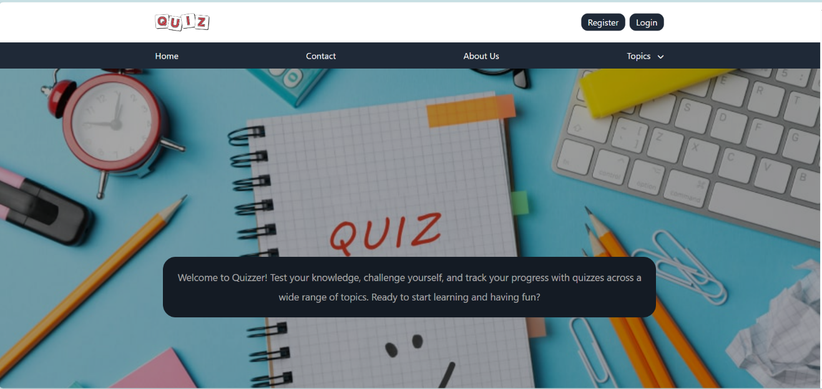

Figure : Landing page

In Figure 1: Landing page, user has options:

* Register for a new user
* Login for registered user

Also, not registered user can view topics or search for topics in the website from the dropdown menu or down in the landing page user can view the following Figure 2: Quizzes in topics:

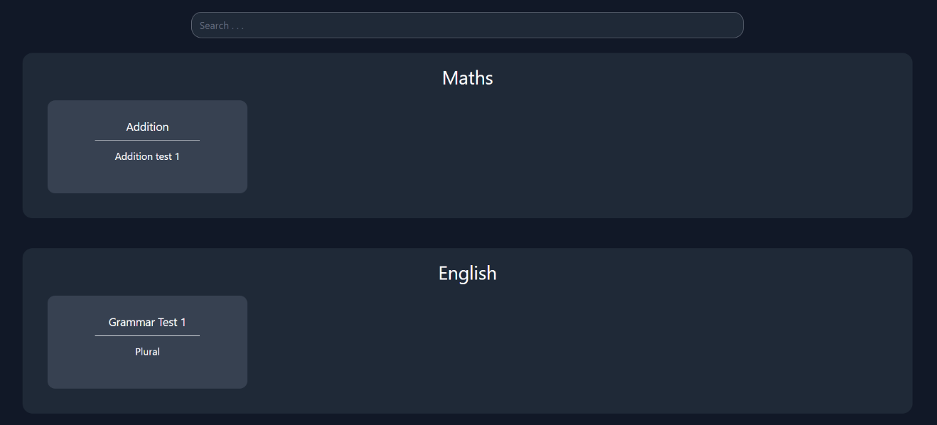

Figure : Quizzes in topics

Register page

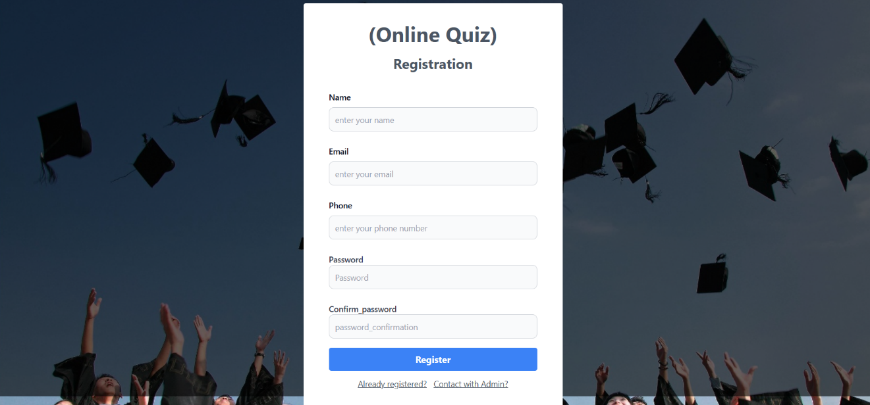

Figure : Register new user

User can register as a new user, and fill these inputs, to be registered. Or if he already has an account, he can go to it.

Inputs have required validation, each input has its own validation in order to make user has a secured experience in the website.

Landing page – Registered user

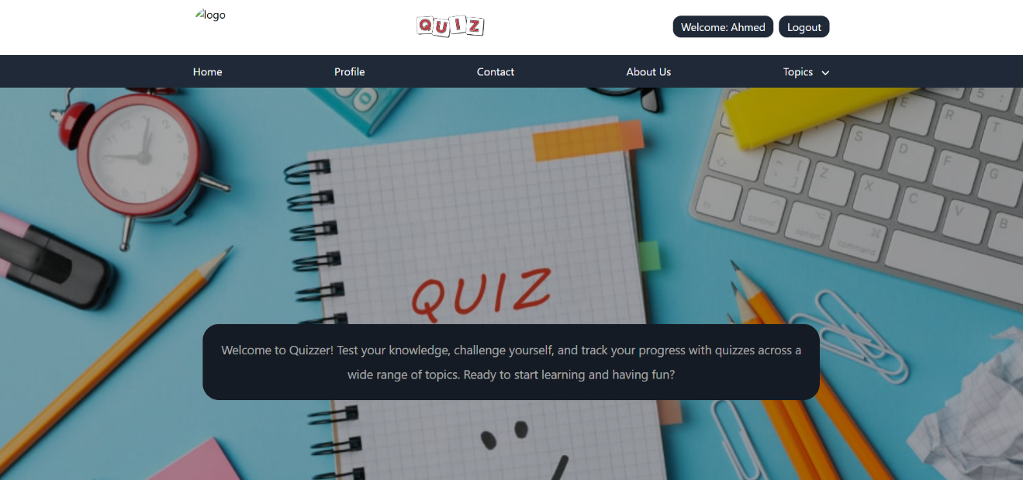



Figure : Landing page - Registered use

Profile page

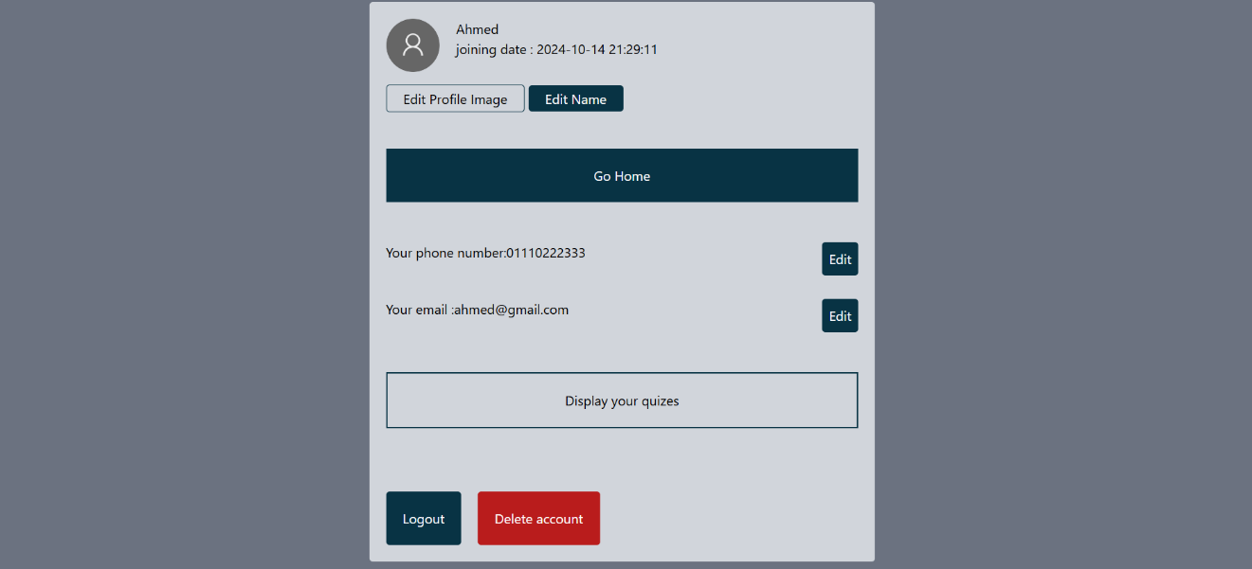

Figure 5: User profile

User can edit, delete, logout and display his own quizzes from this page.

Quiz – user



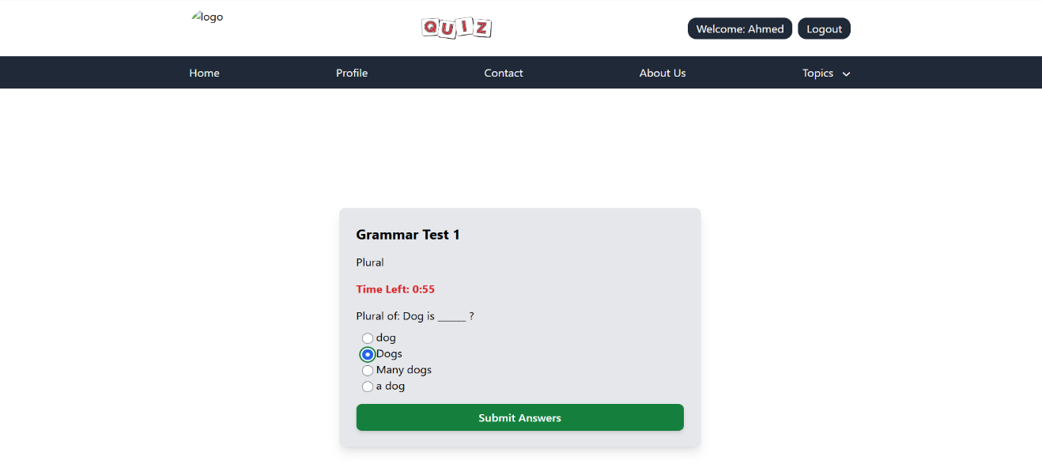



Figure 6: Quiz – User

This page shows a quiz that the user chose to examine. It includes the timer, quiz title, quiz description and submit button.

If the timer is up and the user does not submit any answer, the quiz will be submitted with no answers.

Retake quiz

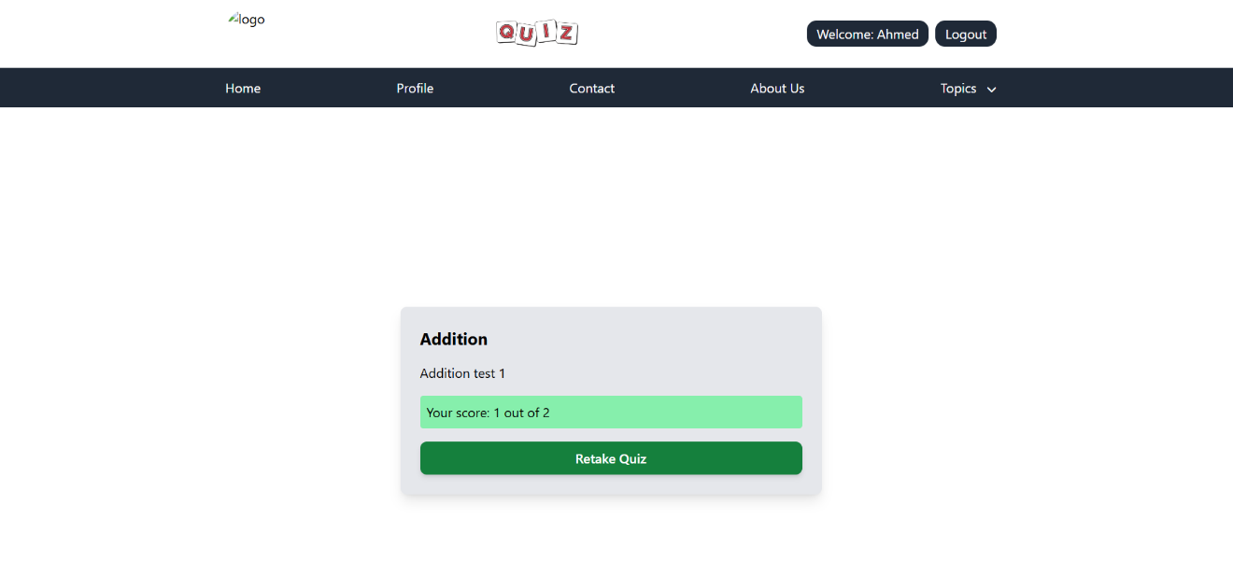



Figure 7: Retake quiz

When user score is below the full mark, user can retake quiz to improve his score.

User feedback

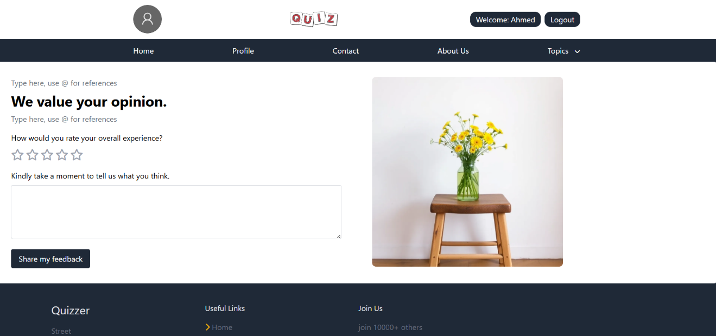

Figure 8: Feedback

In this page user can add and send feedback to the admins, concerning the quizzes the have taken or any messages they need to send.

Admin view

Admin’s landing page



Figure 9: Admin's landing page

Admin has same landing page as students.

Admin should log in with his email and password.

Admin’s homepage

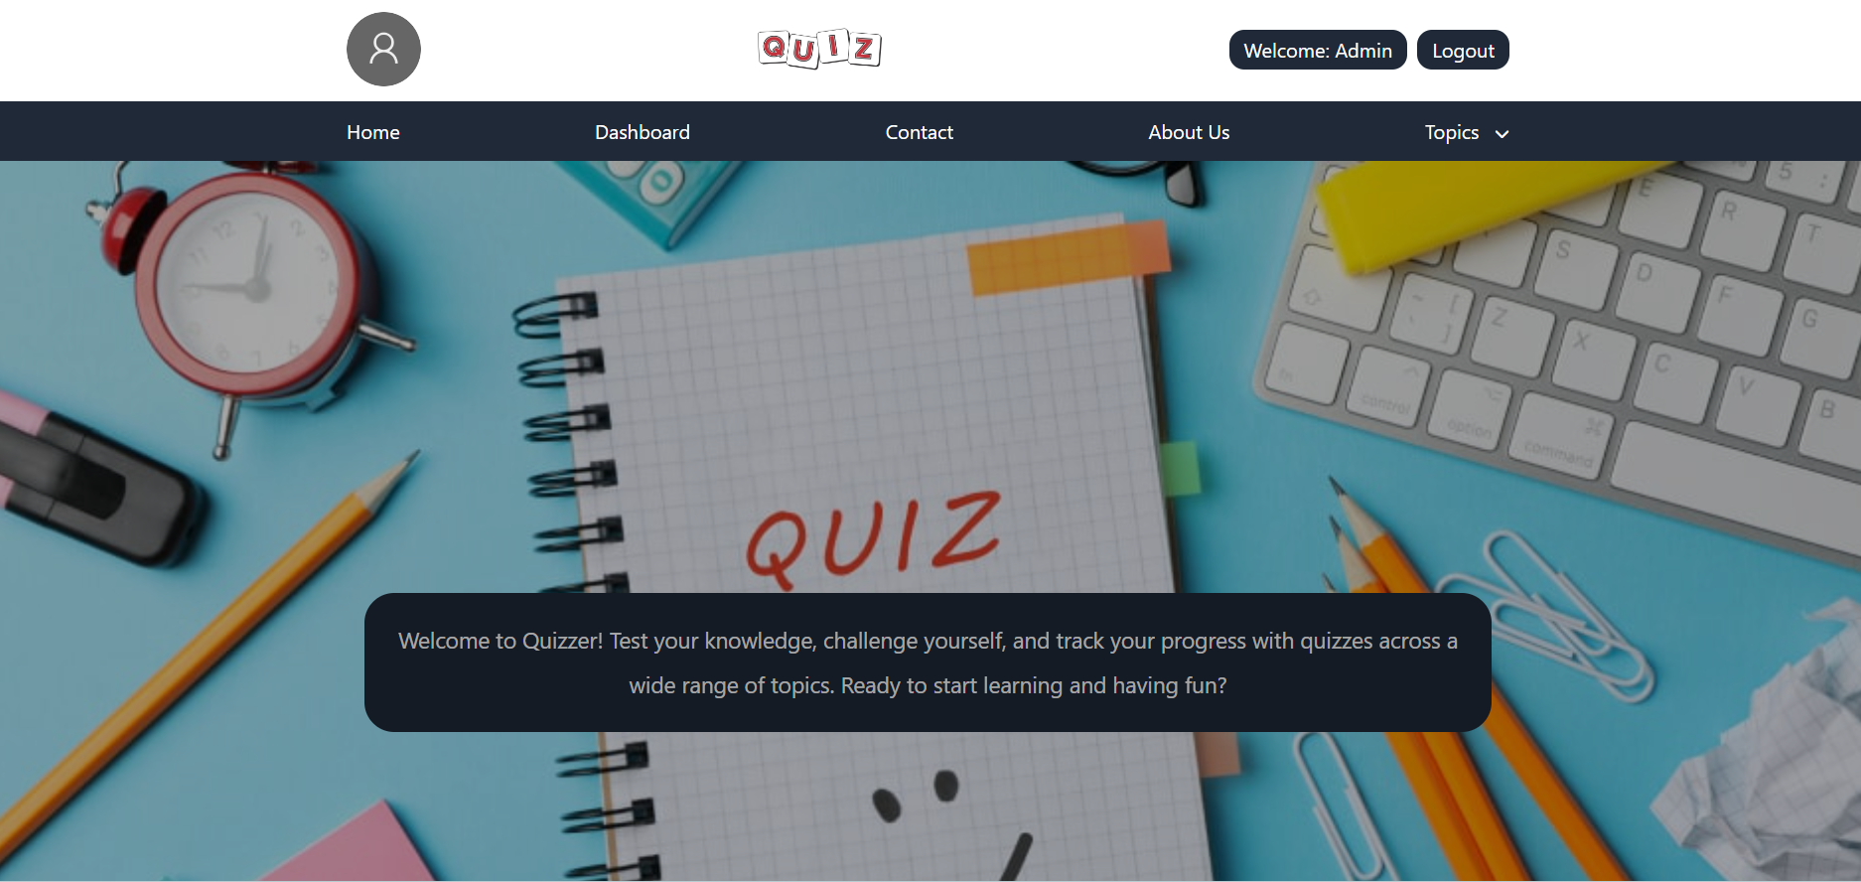

Figure 10: Admin's homepage

Once logged in as an admin. This page is displayed where admin can go to:

* his dashboard to track students progress and quizzes in the library
* navigate the different topics and the quizzes of these topics

Admin’s dashboard

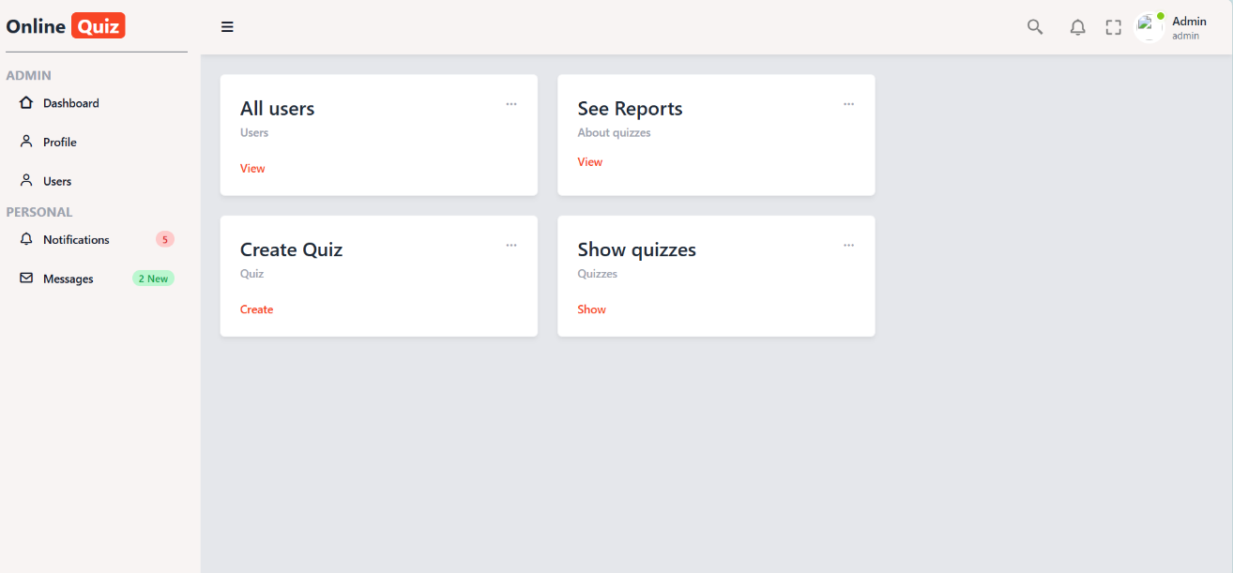

Figure 11: Admin's dashboard

In this page admin has many options, every card has its own use:

* Card 1: Admin can view all users
* Card 2: See reports about quizzes
* Card 3: Create new quiz
* Card 4: View all stored quizzes

Create quiz card

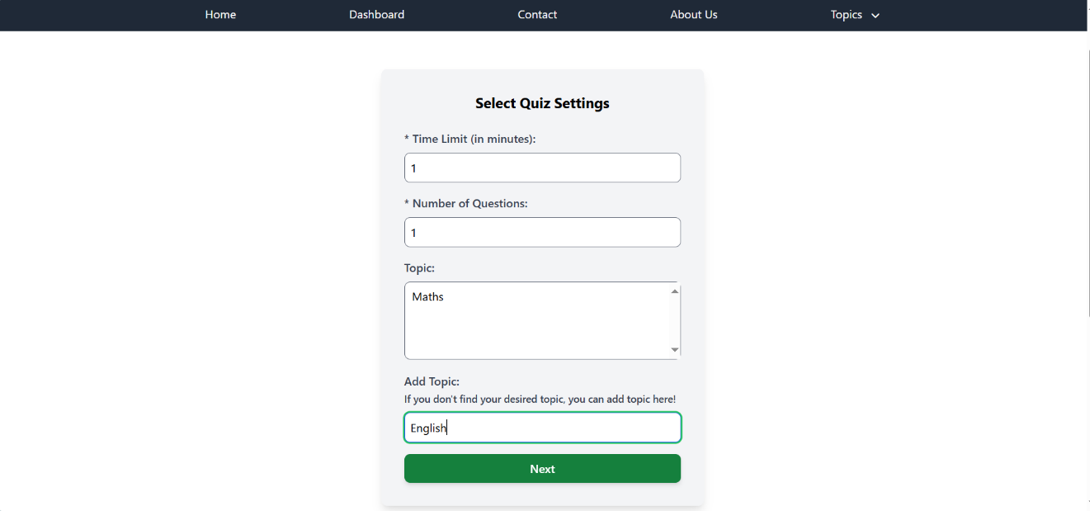

Figure 12: Create quiz

In this form admin can create quiz.

* Admin should first set up quiz settings:
* Insert time limit of this quiz
* Insert number of questions
* Choose topic of the quiz
* Or if topic does not exist, create it
* Then, press next to insert questions

Quiz creation

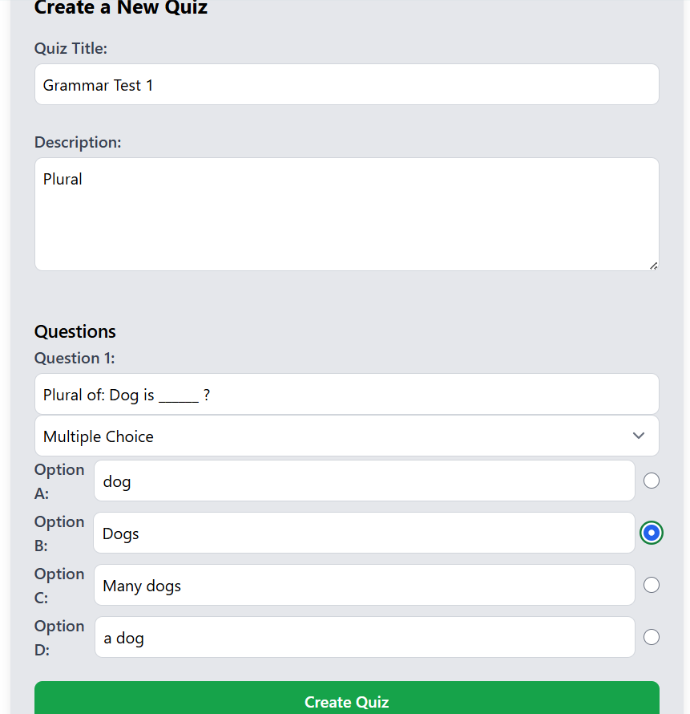

Figure 13: Quiz creation

Admin creates the quiz with the previous set up. He fills the title of the quiz, description and chooses the question type: True/False or Multiple Choices.

Admin must choose a correct answer to be used at scoring the user’s answers.

All users card

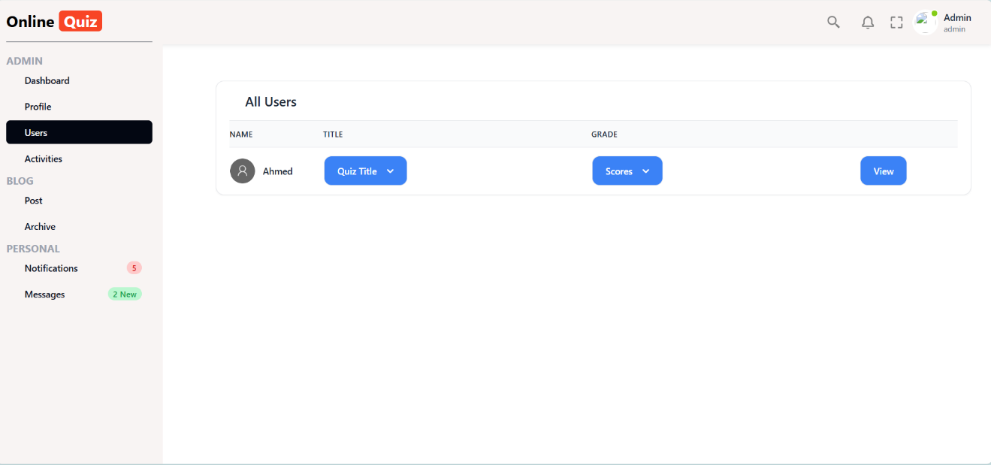

Figure 14: Users

In this page admin can track students and their scores with the quizzes they have taken.

Show quizzes card

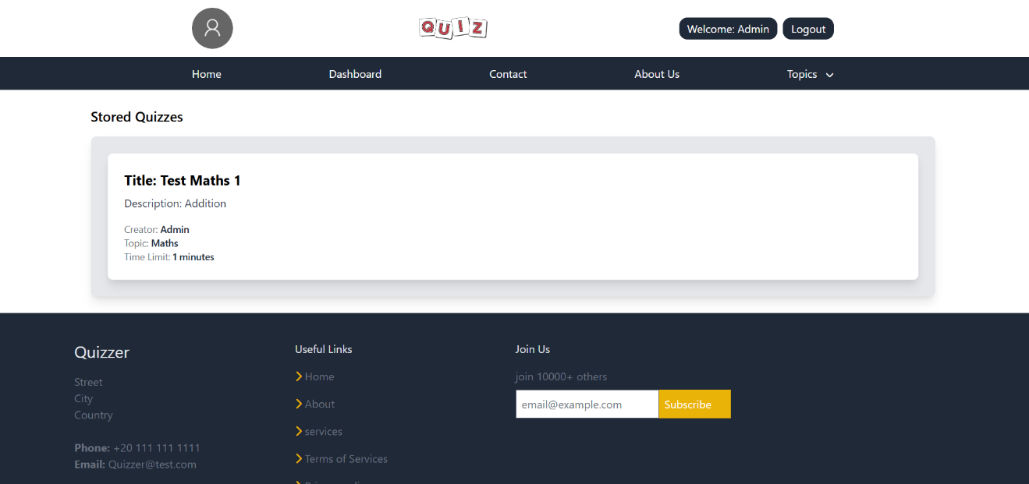

Figure 15: Show quizzes

In this card admin can view all stored quizzes.

See reports card

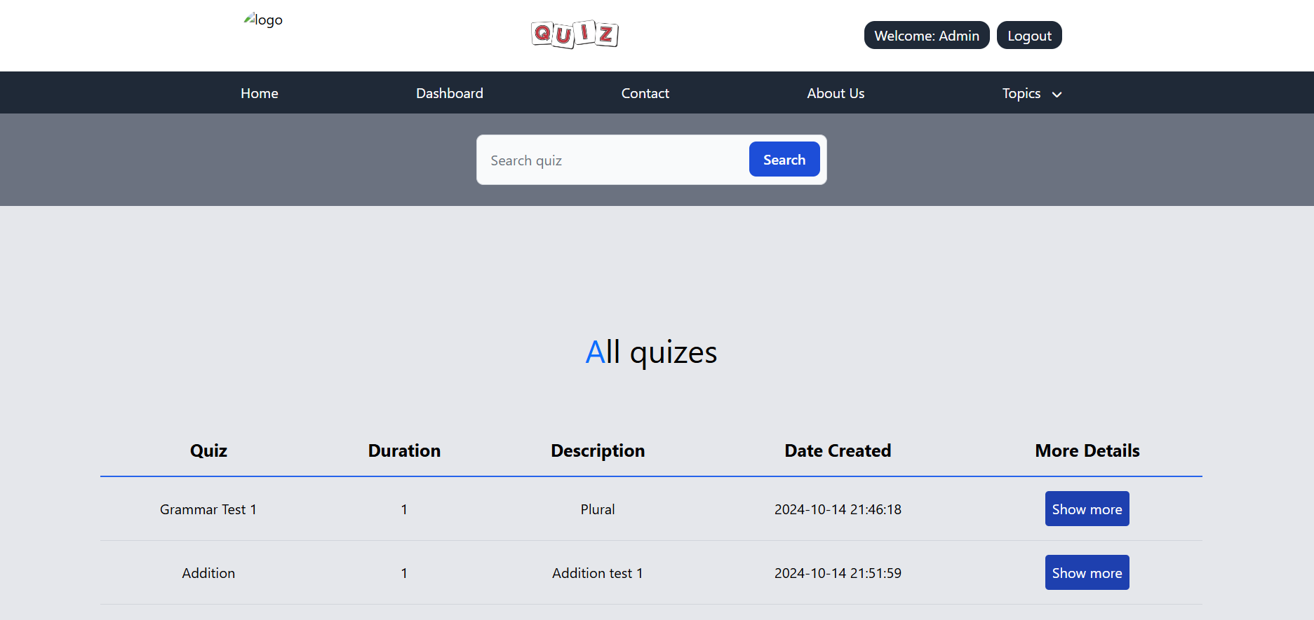



Figure 16: All quizzes

In this page admin can see details abouts quizzes.

Once he presses Show more button:

He will be redirected to a page containing details and info about this quiz and students who have taken this quiz.

Show more button

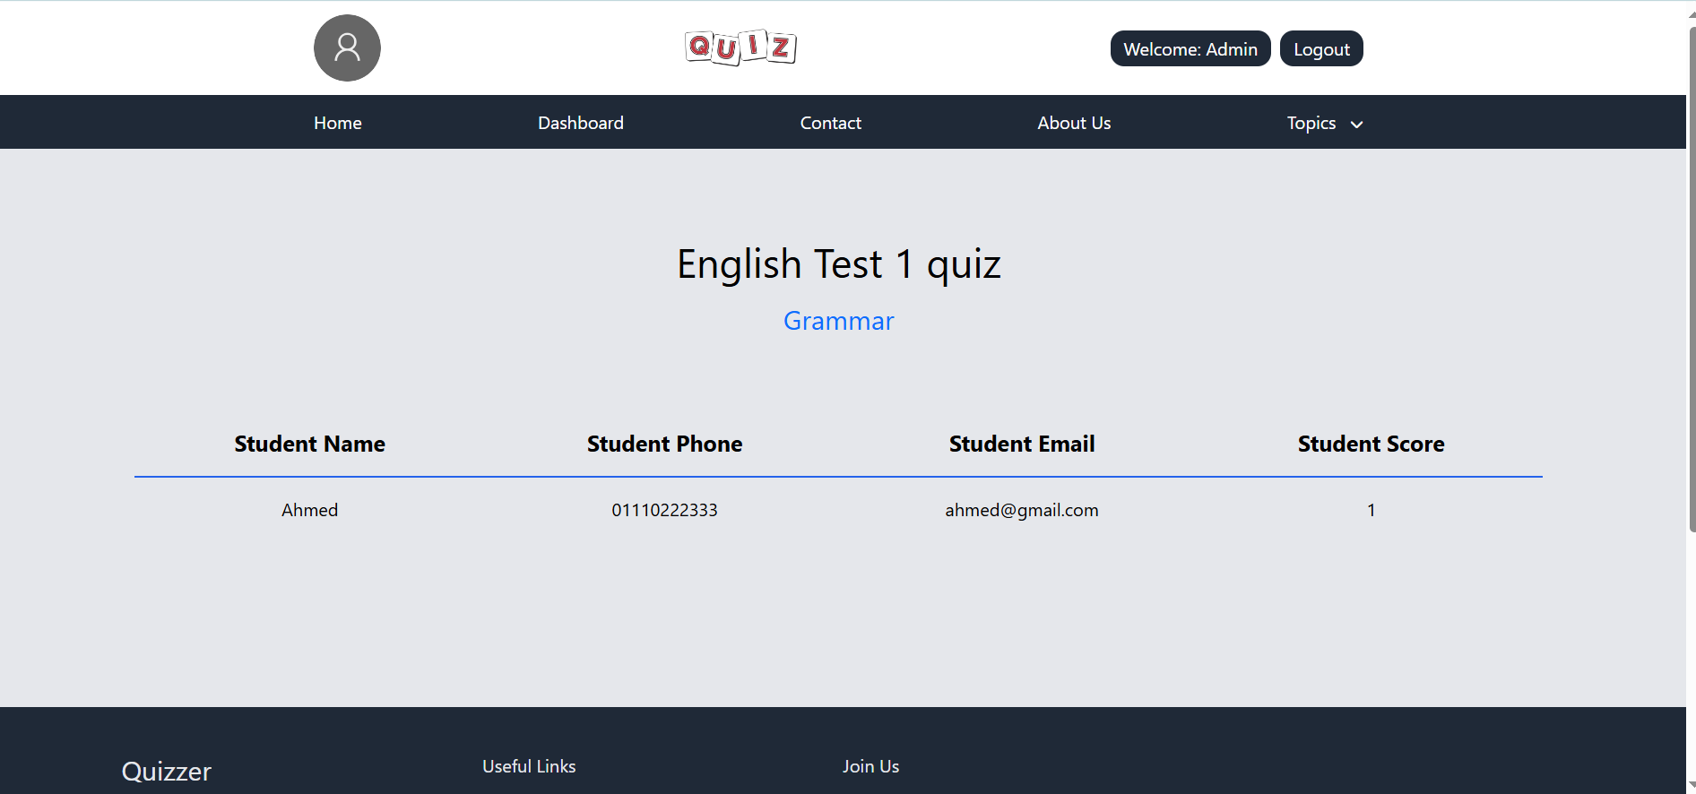

Figure 17: Reports

This page shows the admin:

* the activity done on this quiz
* who are the students who have taken this quiz
* what are their scores.